Unit 15.6 : Refraction and Its Practical Uses
Topic : The disappearing coin
Worksheet 2
Name : _________________
Class : _____________( )
Date : __________________

Task 3 : Relationship between apparent depth and real depth

Procedure:
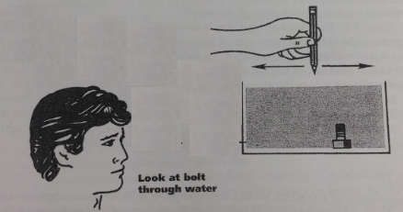
- Place a bolt upright in a large tank of water. Measure the distance between the bolt and the front window (real depth).
- Look at the bolt through the front window of the container and locate the image of bolt by the method of ‘no parallax’.
- Ask another student to measure the distance between the image pen and the front window. This is called the apparent depth of the bolt.
- Move the bolt to other positions. Repeat step 1 to 4 to collect the data.
- Estimate the ratio of real depths and the apparent depths for different positions of bolts.

Results:
 | Real Depth | Apparent Depth | Ratio of  Real Depth to Apparent Depth
Position 1
Position 2
Position 3
Position 4

What conclusion can we draw from the above results?

Ratios of real depth to apparent depth are similar.

Task 4 : Explaining with the concept of refraction

Explain the following cases with the aids of ray diagrams in your group.

- Explain why the swimming pool looks like shallower than its actual depth. What is the implication for swimmers?

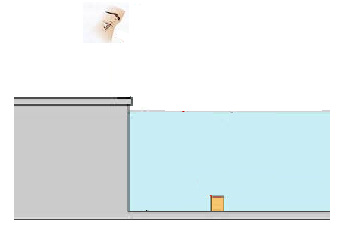

Refraction of light make the apparent depth look shallower than real depth.

- Fishes look bigger in water tank. What is the implication for the consumers?

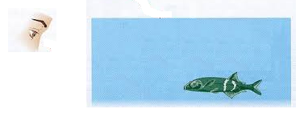

When we choose fishes in water tank, we could ask seller to get the fish out of water.

